Nicaragua

I went to Nicaragua twice, the first time in 2007 and now in 2017. Although it is a small country, there is a lot to do. The city of Managua, the capital of the country, has changed a lot in recent years, and for good. There are almost no ruins of the 1972 earthquake left (on my 2007 trip, there were many), they have put giant decorative trees with lights, created the Salvador Allende Port and Water Park with activities for children, restaurants and walkways by the lake. You can also visit the Old Cathedral and the Revolution Square.

My daughter's father (now deceased) was from Nicaragua. So it's a special destination for us. In Managua we met with the Angie´s grandmother, uncles and cousins. We spent time with family and enjoyed some good Nicaraguan food, we love gallo pinto (rice and beans) and got to travel around together.

A couple of things to consider when travelling to Nicaragua: when arriving at the airport of Managua you must know exactly (as much as possible since the streets have neither name nor number) where you will be staying. Since we were staying with relatives, I had no idea what ​​the address was. They did not let us pass immigration until we got the address. You may also be asked to show for proof of having the yellow fever shot, a requirement if you are coming from South America or Africa, or having spent more than a week in some countries, such as Costa Rica. Luckily, we had the certificate.

Granada is a city south of Managua, just over an hour by mini bus. Keep in mind that buses do not have a/c and you may end up having to travel with no seat, but they are cheap and safe. If you are not used to it, you will find it quite an adventure (lots of yelling and pushing around to get people on board). Granada is a colonial city, which have had some of the historical buildings restored and well set up for tourists (lots of banks and ATM where you can withdrawal córdobas or dollars). There are hotels for all tastes and budgets, bars and restós with tables in the street, at a good price, although not very cheap, around U $ D20 per person, food and a beer. From Granada you can visit Masaya (the city and the volcano), the islets of Granada (there are islands prepared for tourism, with all services included). From Granada you can also go to the Mombacho Volcano.

Weather permitting, the beaches of San Juan del Sur on the Pacific coast are very popular both for tourists and locals. Many choose to go to Corn Island (although I have not done it, yet) on the Atlantic coast. Transportation is very cheap in Nicaragua, and if you get a good driver, it is safe.

To the north of Managua is the city of León, another attractive colonial city. There you can visit different museums and the house of the great Nicaraguan poet, Rubén Darío. Further north is the town of Chinandega, not much to do, too hot and very noisy. We go there to visit family, but stay in the hotel with a/c most of the time.

If you want more information about Nicaragua and a one-week itinerary proposal, read below.

By Lolo

NICARAGUA

TOP 5 places to visit:
- Granada
- Mombacho
- Masaya
- San Juan del Sur
- León

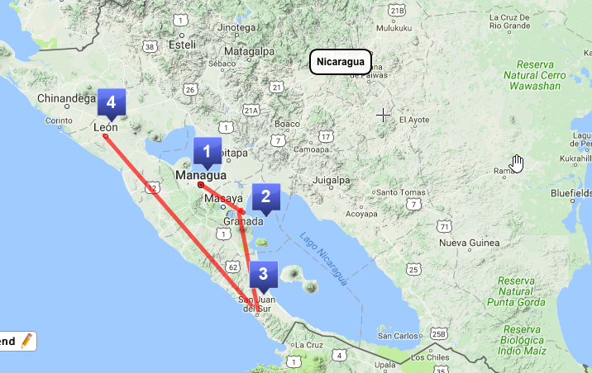

 | DAY 1 | DAY 2 | DAY 3 | DAY 4 | DAY 5 | DAY 6 | DAY 7
ACTIVITIES | Travel Day  Visit  Managua  downtown | Granada | Granada  Mombacho | Granada  Masaya | San Juan del Sur | León | Travel Day

Day 1: Arrive in Managua airport – MGA. Depending time of arrival, you can take a quick tour around downtown Managua. Ask the hotel to get a taxi that can take you around. Managua has suffered an earthquake in 1972, and most monuments have not been restored. But still worth a visit to some of the historical places. Visit the Antigua Catedral (Old Cathedral), the Plaza de la Revolución (Revolution Plaza) and the Malecón (Pier). If you stay at night, you can go to Chamán Bar for music and drinks. You may also choose to go directly to Granada, as many visitors do.
[foto]

Day 2: Travel to Granada. It is a beautiful and elegant colonial town. Some people use Granada as their base town for the whole trip. You can take a bus: $0.75-1.25 for 1 hr or a taxi for around $50. There, walk around town and enjoy the wonderful town with its churches, museums, restaurants and bars. You can also take boat tour of the isletas (more than 300).
[foto]

Day 3: Granada: Visit the Reserva Natural Volcán Mombacho $20. You can take a hike and visit an organic coffe farm, see monkeys and wild orchids. or visit the mariposario (butterfly garden) and the jardín de las orquídeas (orchid garden).

Day 4: Masaya: Not as beautiful as Granada, but a great place to buy souvenirs at the famous artisan market (Mercado Artesanal de Masaya). It is only 16 km from Granada. You can visit the Parque Nacional Volcán Masaya. You should ask when travelling if it is open, as sometime closes due to volcanic activity.

Day 5: San Juan del Sur: A southern Pacific beach, visited by most international travelers and surfers. Good options for restaurants, bars and nightlife places. Only 2½ hr from Managua, you can take a bus for $3.25. From Granada, only 40 min. $0.50.
[foto]

Day 6: León is around 1½-2 hr trip by bus from Managua, and it cost between $1.50-2.75 depending on service you take. This is another wonderful and busy colonial town, with churches, museums, art collections, beautiful streets, many restaurants and a decent nightlife. Visit the Catedral de León (Cathedral), Museo Rubén Darío (the great Nicaraguan poet), Museo de leyendas y tradiciones (Legends and Traditions Museum) fee $2, a very interesting museum, and you can also visit the many churches and ruins the town has.

Day 7: Head back to Managua for your flight home.

